**Labsheet-1**

Tammalla Rahul

AM.EN.U4CSE17335(REDO)

1. Display the path of your current directory.



2)Make a new directory named ***main***.



3)Now go to the directory ***main***.



4)Make the directories in the following hierarchy using a single command.

 Dir1 -> Dir2 -> Dir3



5)Print the path of the current directory.

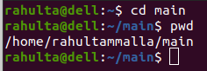

6)Go to ***Dir3*** using a single command.



7) Create a new file ***demo1***, type and save the following contents,

This is my first file in shell.

I can edit this file!!!



8) Create a new file ***demo2***, type and save the following contents,

Hi!!! This is the second file.

I am doing shell commands.

I can edit this file!!!

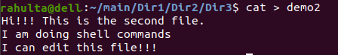

9)Display the contents of file ***demo1*** in terminal.



10)List the files and folders present in ***Dir3***.



11)Go to ***Dir 2***.



12)Go to your home directory.



13)Stay where you are, and list the contents of ***Dir3***.

>ls main/Dir1/Dir2/Dir3

14)List all the files (including hidden files) in your home directory.

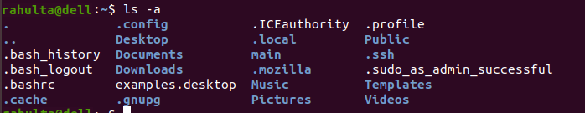

15)Create a new file **test1**, type and save the contents into your file.

I am working with linux shell.

Good bye



16)Copy the contents of **test1** to **test2** in the same directory.



17) Rename **test2** as **test3**.

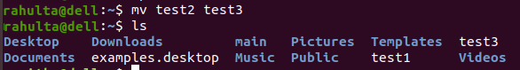

18) Determine the file type of **test3**.



19)Move the file **test3** to the directory Dir3.



20) Create a file **count**, with content one to twenty in words with one line having only one number using a single command.

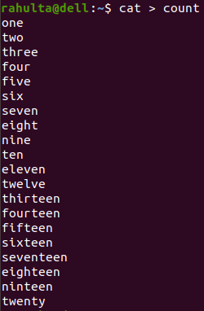

21) Copy the file **count** to **count2** using cat command.



22) Create another file **count3**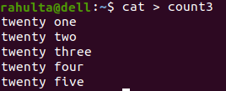 with numbers twenty one to twenty five (in five lines).

23) Concatenate the contents of files **count2** and **count3** and write it into the file **countfinal**.



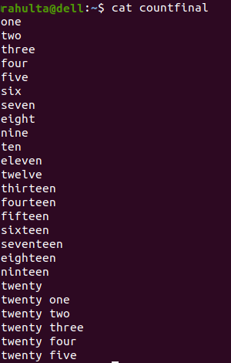

24)Remove the files **demo1** and **demo2** in directory Dir3.

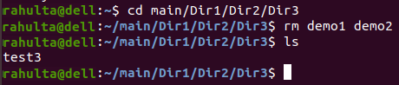

25) Go to Dir2 and remove the subdirectory Dir3.

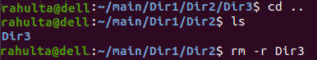

26)Come back to your home folder and remove Dir2.

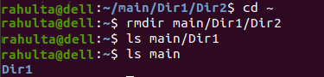

27)Display first 10 lines of the file **countfinal** in terminal.

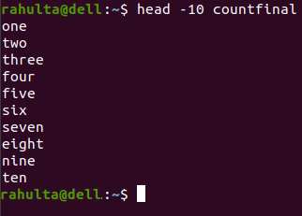

28) Display last 10 lines of the file **countfinal** in terminal.

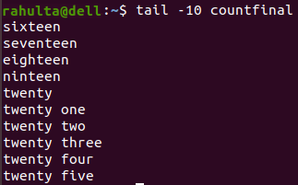

29) Display first 5 lines of the file **countfinal** in terminal.

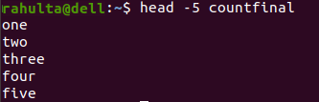

30) Display last 4 lines of the file **countfinal** in terminal.

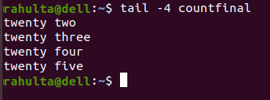

31)Display the contents of the file **countfinal** in the inverted form. (last line first and first line last)

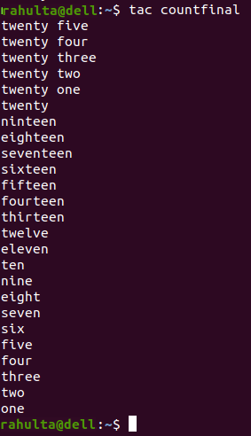

Rahul tammalla

(AM.EN.U4CSE17335)

REDO